☕ Data Types in Java – Complete Beginner Guide
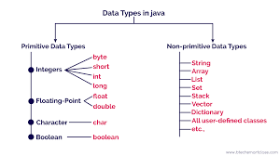
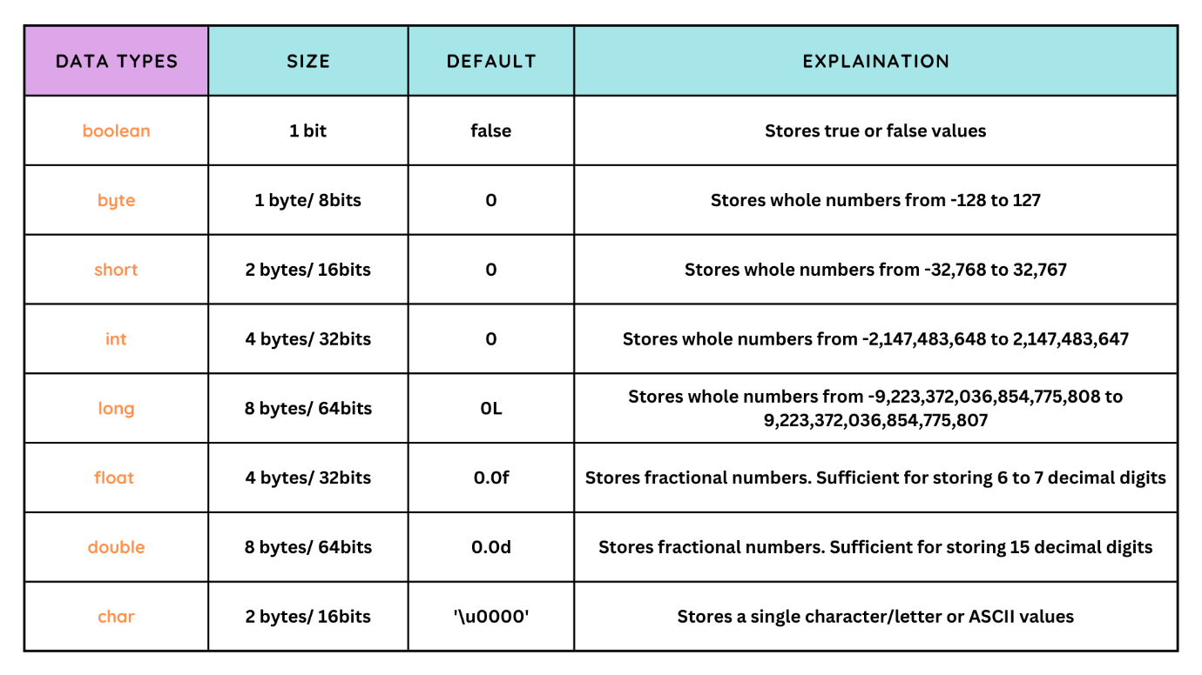
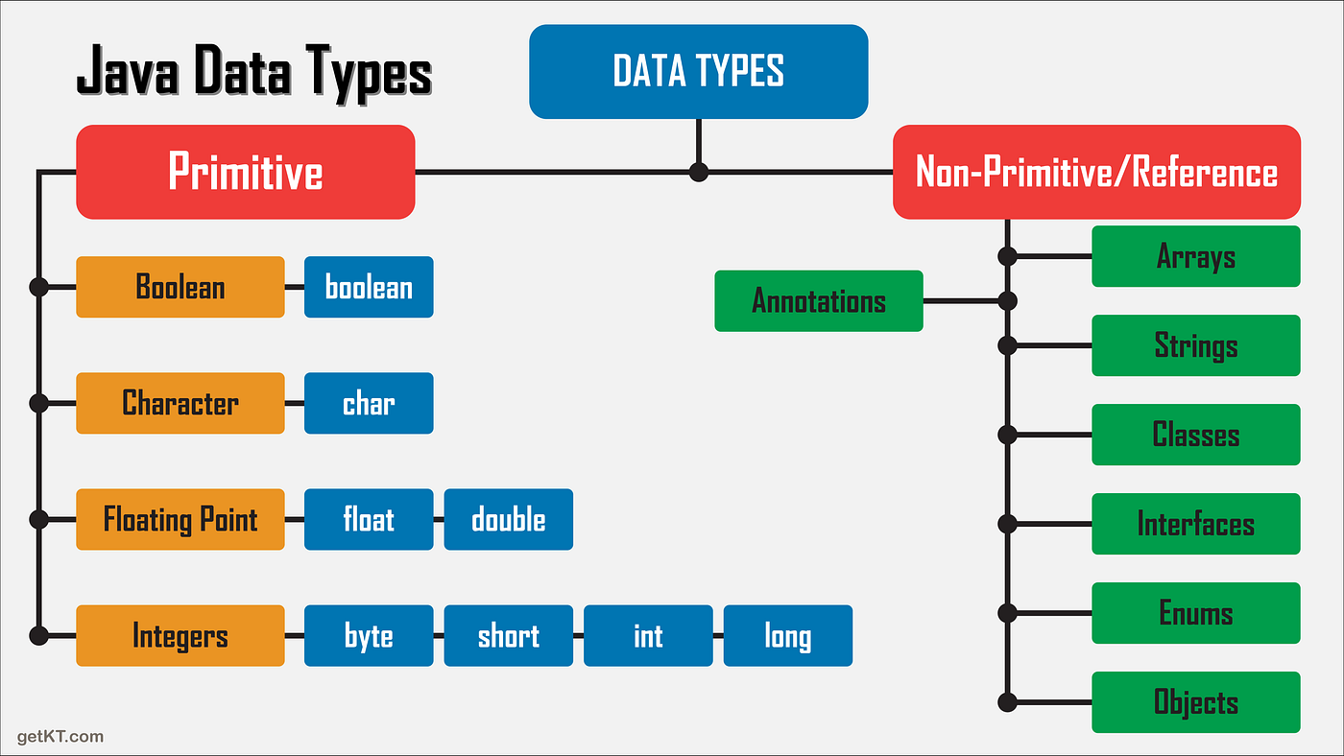

🔷 What is a Data Type in Java?
A data type tells Java:
- What kind of data a variable can store
- How much memory is required
- What operations are allowed on that data
👉 Without data types, Java wouldn’t know how to store or process values.

🔶 Why Data Types Are Important?
- Ensure correct memory allocation
- Prevent invalid operations (e.g., adding text to numbers)
- Improve performance
- Make programs safe and predictable

🧩 Types of Data Types in Java
Java has two main categories:
1️⃣ Primitive Data Types
2️⃣ Non-Primitive (Reference) Data Types

1️⃣ Primitive Data Types in Java
What is a Primitive Data Type?
Primitive data types:
- Store simple, single values
- Are predefined by Java
- Do not store object references
- Are faster and memory-efficient
📌 Java has 8 primitive data types

📊 List of Primitive Data Types
Data Type | Size | Stores | Example
byte | 1 byte | Small integers | -128 to 127
short | 2 bytes | Medium integers | -32,768 to 32,767
int | 4 bytes | Integers | 25, 1000
long | 8 bytes | Large integers | Population
float | 4 bytes | Decimal values | 75.5
double | 8 bytes | Large decimals | Salary
char | 2 bytes | Single character | 'A'
boolean | 1 bit | True/False | true

🔹 1. int – Integer Numbers
Purpose
Stores whole numbers.
Example
int age = 25;
int marks = 480;
Real-World Example
- Age of a person
- Number of students
- Quantity of items

🔹 2. double – Decimal Numbers
Purpose
Stores decimal values with high precision.
Example
double salary = 45678.75;
double temperature = 36.6;
Real-World Example
- Employee salary
- Bank interest
- Temperature readings
📌 Most commonly used for decimals.

🔹 3. float – Decimal (Lower Precision)
Purpose
Stores decimal values but less precise than double.
Example
float percentage = 78.5f;
📌 f is mandatory.
Real-World Example
- Exam percentage
- Sensor values

🔹 4. char – Single Character
Purpose
Stores one character.
Example
char grade = 'A';
char gender = 'M';
Real-World Example
- Grade (A, B, C)
- Gender (M/F)
- Yes/No (Y/N)
📌 Uses single quotes.

🔹 5. boolean – True or False
Purpose
Stores logical values.
Example
boolean isActive = true;
boolean isLoggedIn = false;
Real-World Example
- Account active/inactive
- Payment success/failure
- User logged in or not

🔹 6. byte – Very Small Integer
Purpose
Stores small integer values.
Example
byte age = 30;
Real-World Example
- Age (small values)
- Network data packets
📌 Saves memory in large arrays.

🔹 7. short – Medium Integer
Purpose
Stores integers bigger than byte but smaller than int.
Example
short year = 2025;
Real-World Example
- Year
- Small counters

🔹 8. long – Very Large Integer
Purpose
Stores very large numbers.
Example
long population = 1400000000L;
📌 L is mandatory.
Real-World Example
- Country population
- Bank account numbers
- Large IDs

🧠 Primitive Data Types – Real-World Scenario
Employee Management System
int empId = 101;
char grade = 'A';
double salary = 55000.75;
boolean isPermanent = true;
Explanation
- int → employee ID
- char → grade
- double → salary
- boolean → employment status

⚠️ Important Rules (Exam & Interview)
✔ Primitive types store values directly
✔ They are not objects
✔ They have fixed size
✔ Faster than reference types
❌ Cannot call methods on primitives

🔁 Primitive vs Non-Primitive (Quick Comparison)
Feature | Primitive | Non-Primitive
Stores | Value | Reference
Size | Fixed | Varies
Speed | Fast | Slower
Examples | int, char | String, Array
Methods | ❌ | ✔

🏁 Final Summary
- Data types define what data a variable can store
- Primitive data types store simple values
- Java has 8 primitive types
- Used in every Java application
- Foundation for Core Java & OO

Example
package com.demo1;

public class PrimitiveTypeDemo {
public static void main(String[] args) {

// 1. byte - Small numerical value
byte experienceYears = 5;

// 2. short - Medium range number
short branchCode = 1023;

// 3. int - Whole numbers
int empId = 101;

// 4. long - Large numerical value
long companyRevenue = 15000000000L; // yearly revenue

// 5. float - Decimal with less precision
float attendancePercentage = 92.5f;

// 6. double - Decimal with high precision
double salary = 55000.75;

// 7. char - Single character
char grade = 'A';

// 8. boolean - True or False
boolean isPermanent = true;

// Printing all values
System.out.println("Employee Experience (Years) : " + experienceYears);
System.out.println("Branch Code : " + branchCode);
System.out.println("Employee ID : " + empId);
System.out.println("Company Revenue : " + companyRevenue);
System.out.println("Attendance Percentage : " + attendancePercentage);
System.out.println("Employee Salary : " + salary);
System.out.println("Employee Grade : " + grade);
System.out.println("Is Permanent Employee? : " + isPermanent);

}

}

1️⃣ byte – Smallest Integer Type
Size
- 1 byte
Maximum Value
- 127
When to Use byte?
✔ When memory is critical
✔ Large arrays with small values
✔ Network packets
Real-World Example
byte age = 25;
📌 Example usage:
- Age
- Small counters
- Status codes

🔹 2️⃣ short – Small to Medium Integers
Size
- 2 bytes
Maximum Value
- 32,767
When to Use short?
✔ When byte is too small
✔ To save memory over int
Real-World Example
short year = 2025;
📌 Example usage:
- Year
- Small IDs
- Department codes

🔹 3️⃣ int – Default Integer Type ⭐
Size
- 4 bytes
Maximum Value
- 2,147,483,647
When to Use int?
✔ Most commonly used
✔ Default choice unless reason otherwise
Real-World Example
int empId = 101;
📌 Example usage:
- Employee ID
- Product quantity
- Count of records

🔹 4️⃣ long – Very Large Numbers
Size
- 8 bytes
Maximum Value
- 9,223,372,036,854,775,807
When to Use long?
✔ Very large numbers
✔ Values beyond int range
Real-World Example
long population = 1400000000L;
📌 Example usage:
- Population
- Bank account numbers
- Company revenue
⚠️ Always use L suffix

